User Interface Design

for

The Gizzy Gallery

**Authors:**

Zyad Ahmed,

Rostam Boroumand Rad,

Alina Momin,

Wes Robinson,

Thomas Wang,

Huzaifa Zia

UMBC

10/05/2022

**Table of Contents**

**Table of Contents ii**

**Revision History ii**

**1.** **Introduction 3**

**2.** **User Interface Standards 3**

**3.** **User Interface Designs**  3

**Revision History**

| **Name** | **Date** | **Reason For Changes** | **Version** |
| --- | --- | --- | --- |
| Rostam B. Rad | 10/22/22 | Wrote UID | 1.0 |
| Alina Momin | 12/2/22 | Updated UID with graphical interfaces as well as updating design clarifications | 1.1 |

# Introduction

1.1 The purpose of this document is to showcase the User Interface of our family photo album. This document will go over the first page that users will see which is the login screen. It will also go over how the main page will look like after a successful log in.

# User Interface Standards

The design standards for this program is to maintain a consistent flow throughout the menus, text font, button design, and color scheme. We will take full advantage of abstraction so users do not have to worry about how the program works. We want to allow users to have an enjoyable experience and only allow actions that will not cause errors. The actual program will be a web application created with REACT so the main navigation will be with the scroll wheel. Photos will be able to be dragged and dropped into the app and error handling will ensure the correct file type is inserted.

# User Interface Designs

# Login/Register

## 

The login screen will be very clean and simple, it will be easy for users to navigate. If the user does not have an account, the login screen includes an option to `Create an Account`. If the user has a registered account, they can login and stay logged in by selecting `Remember me`.

If users do not have an account they can sign up for one by clicking on create an account. Users will then be prompted to enter general information as shown below:

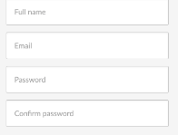

If users have forgotten their password then they can click on the ”Forgot my password” which will send a reset password link to their email address. We will also be implementing two factor authentication as security is important for our user’s data.

## Home/Gallery Screen

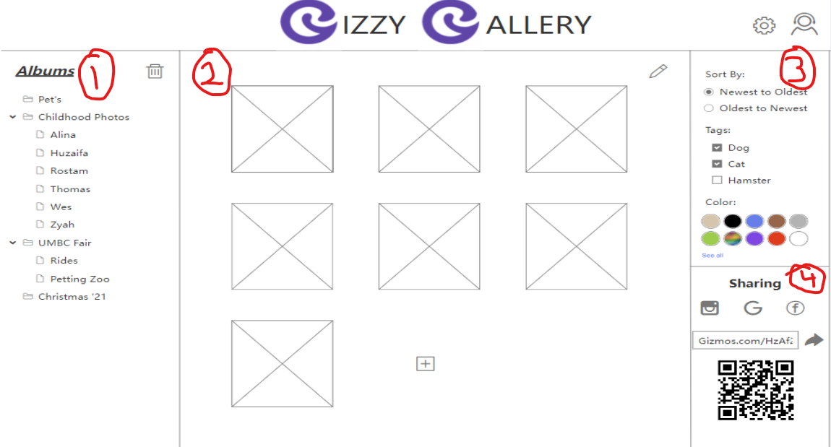

The Gallery will be populated with user uploaded files. The gallery will include a directory of `Albums` on the left, the users will have the option to add and delete files from the specific albums. The right hand side of the gallery will consist of data to sort the images. Metadata such as color, date and user assigned tags will be used to sort files. The users will also be able to share their files using a QR code or through various social platforms.

1. On the left hand side users will be able to view all of their stored photo albums and be able to view the photos inside by clicking on each folder
2. The middle section will display the user's stored photos once inside a folder. Users will be able to click the “add” button to insert new photos and be able to add tags to go along with the picture that can later be used to sort the photos.
3. Section 3 on the top right side will allow users to sort the photos depending on different parameters. Some options we are working on implementing will be sorting the photos by data they were taken/added, sorting by tags, and sorting by color of photos.
4. In section 4 on the bottom right hand side. Users will be able to share their photo albums with other users and have them collaborate and add photos to the album. We will allow the owner to give edit permissions or view only permissions to other users. The album can either be shared via a personalized link or a QR code.

The main application will only have one page that the user can scroll down to view all pictures. However modal style windows will pop up when sharing with other users or adding a new photo. In these cases users can either click on the empty spaces on the left and right side to exit the modal or click on the “X” to close the window.